**NOTE: This is an official document by Indexademics. Unless otherwise stated, this document may not be accredited to individuals or groups other than the club IDX, nor should this document be distributed, sold, or modified for personal use in any way.**

**IDX G9 Physics S STUDY GUIDE ISSUE 6**

**By Joyce and Virginia**

**Chapter 7 Gravitation**

**Section 7.1 Planetary Motion**

**Models of Planetary Motion**

1. Geocentrism:

Earth is the center of the universe (400 BC-1600 AC)

Early supporters: Aristotle and Zhang Heng

1. Ptolemy’s Model:

Sun and planet orbited Earth

He accounted for the irregular motion of planets by using spinning wheels – epicycles

1. Tycho Brahe:

Build instruments to measure position of planets and stars accurately

Sun and moon orbit earth, other planets orbit sun

1. Heliocentrism:

Moon revolves around Earth

Earth and other planets revolve around sun

Nicolaus Copernicus: first human to propose planets revolve around sun

1. Johannes Kepler

Discovered laws that describe motion of every planet by analyzing Brahe’s data

**Kepler’s Laws**

1. Kepler’s first law

Paths of planets are called ellipses, with the Sun at one focus

Planets, stars, comets all orbit sun in ellipses

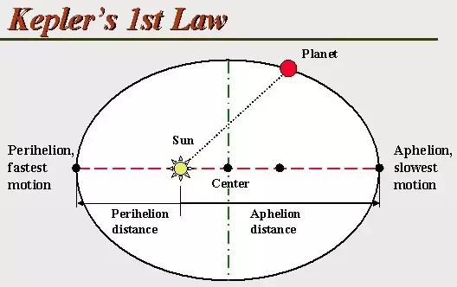

1. Kepler’s second law

An imaginary line from Sun to a planet sweeps out equal areas in equal time intervals

Planet closer to sun -> move faster (and vice versa)

1. Kepler’s third law

The square of the ratio of the periods of any two planets is equal to the cube of the ratio of their average distances from the Sun.

T1, T2= period of planets

r1, r2= average distance of planets from sun

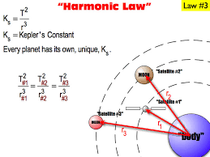

**Law of Universal Gravitation**

* Objects attract other objects with a force that is proportional to the product of their masses and inversely proportional to the square of the distance between them.
* Gravitational force acts between any two objects, anywhere in the universe

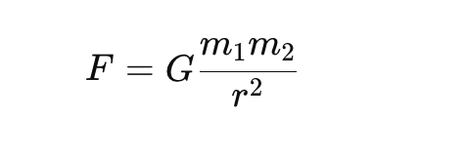

F- gravitational force between 2 objects

G- gravitational constant (6.67x 10^-11 Nm2/kg2)

m 1, m2- mass of 2 objects

r- distance between centers of the 2 objects

**Universal Gravitation and Kepler’s Third Law**

Newton’s law agreed with Kepler’s third law

When calculating, we assume planet is orbits Sun in a circular orbit (in reality the orbit is an ellipse)

* For a planet orbiting the Sun (uniform circular motion), the universal gravitational force provides the centripetal force

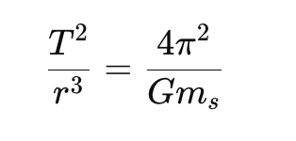

* Period of a planet orbiting sun

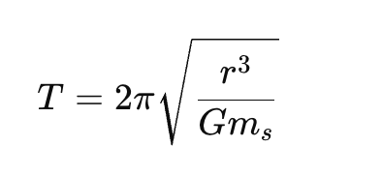

**Measuring Universal Gravitational Constant**

* Through Cavendish’s experiment (aka weighing Earth)
* Cavendish helped determine earth’s mass

* Fg= mass x acceleration due to gravity
* Mass of Earth= 5.98 x 10^24 kg
* There is an attractive gravitational force between any two objects
* But force between everyday objects is so small that it can’t be observed

**7.2 Using the Law of Universal Gravitation - Notes**

1. Newton’s Thought Experiment

• A cannonball is a projectile.

• If the speed is not large enough, it will follow a parabolic trajectory and fall back to the ground.

• If the speed reaches orbital velocity, it will enter an orbit around the Earth.

• At this point, the curvature of the cannonball’s path matches the curvature of the Earth.

• If the speed is greater than orbital velocity but less than escape velocity, the cannonball will follow an elliptical orbit around the Earth.

• If the speed is very high, the cannonball will follow a parabolic trajectory (exactly at escape velocity) or a hyperbolic trajectory, leaving the Earth.

2. Orbital Speed

• A satellite orbiting the Earth at a constant height moves in uniform circular motion.

• The net centripetal force is provided by gravitational force:

• Where:

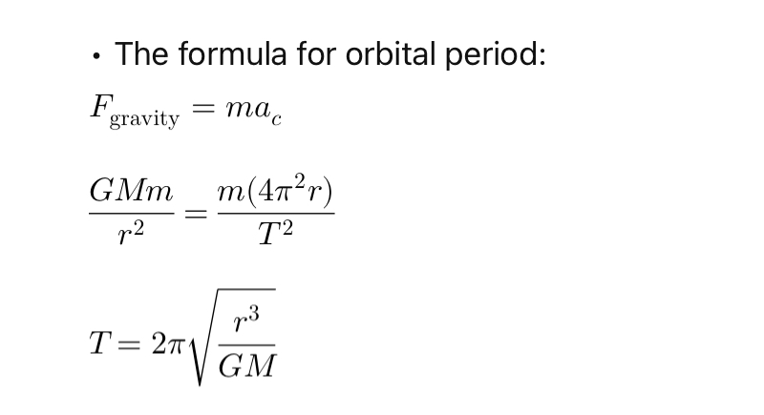

• G is the gravitational constant

• M is the mass of the Earth

• r is the orbital radius (Earth’s radius + orbital height)

How to calculate V?



• Escape Velocity

• The minimum velocity needed for an object to escape a celestial body’s gravity without additional propulsion.

• Black holes have extreme gravity, causing their escape velocity to exceed the speed of light, preventing light from escaping.

3. Orbital Period

• The formula for orbital period:

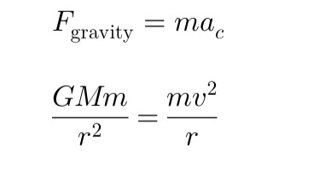



• Practice Problem

A satellite orbits 225 km above Earth’s surface. Given:

• Mass of Earth: kg

• Radius of Earth: m

Find the orbital speed and period of the satellite.

Summary

1. Orbital motion is maintained by gravitational force acting as a centripetal force.

2. Orbital speed depends on the orbital radius; it decreases as altitude increases.

3. Escape velocity is the minimum speed required to leave a celestial body’s gravitational pull; it does not depend on mass but depends on the celestial body’s mass and radius.

4. The orbital period is proportional to the 3/2 power of the orbital radius.